Data Center
- Physical facility
- Hosting for group of networked servers
- Own power, cooling & networking infrastructure
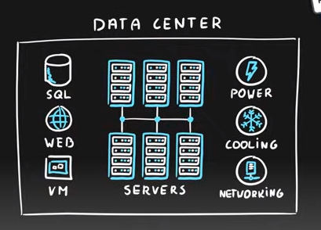

Region
- Geographical area on the planet
- One but usually more datacenters connected with low-latency network (<2 milliseconds)
- Location for your services
- Some services are available only in certain regions
- Some services are global services, as such are not assigned/deployed in specific region
- Globally available with 50+ regions
- Special government regions (US DoD Central, US Gov Virginia, etc.)
- Special partnered regions (China East, China North)
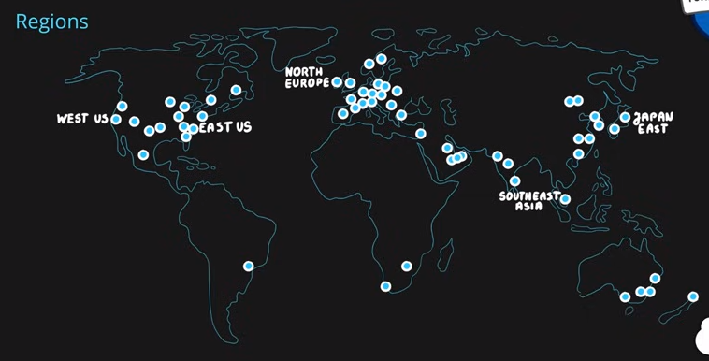
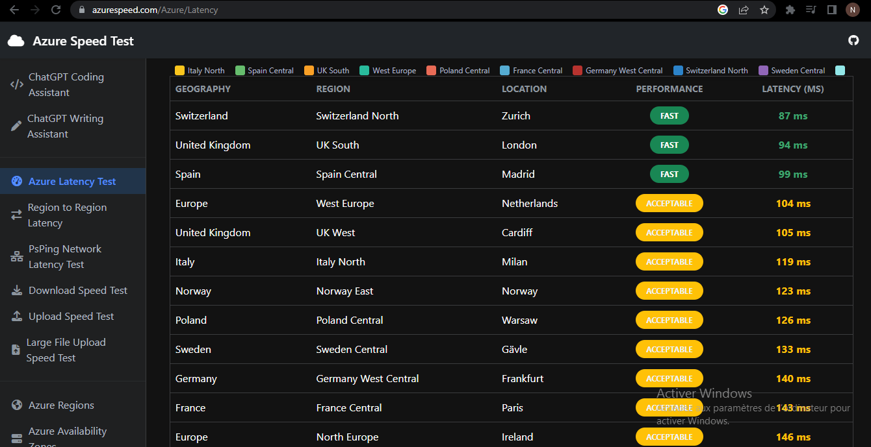
Azure Speed Test / Latency Test
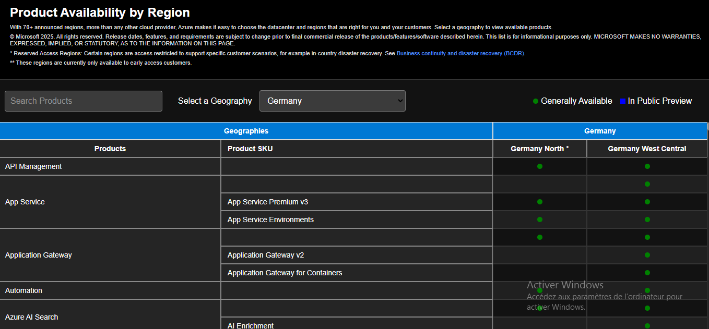
Azure Products Availability per Region
Therefore, when choosing the Azure region you should first check the closest ones like top 2 or 3 nearest regions and then decide based on the product availability.

Availability Zone
- Regional feature
- Grouping of physically separate facilities
- Designed to protect from data center failures
- If zone goes down others continue working
- Two service categories
  - Zonal services (Virtual Machines, Disks, etc.) meaning choose where/which data center or availability zone to deploy to.
  - Zone-redundant services (SQL, Storage, etc.) these take advantage of the available datacenters automatically by replicating the data with a click of a button/option for redundancy.
- Not all regions are supported
- Supported region has three or more zones
- A zone is one or more data centers
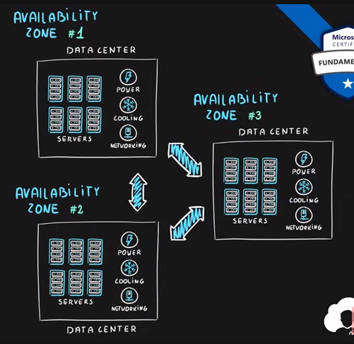
Region Pair
- Each region is paired with another region making it a region pair
- Region pairs are static and cannot be chosen
- Each pair resides within the same geography*
  - Exception is Brazil South
- Physical isolation with at least 300 miles distance (when possible)
- Some services have platform-provided replication
- Planned updates across the pairs
- Data residency maintained for disaster recovery
Region Pair A | Region Pair B
East US | West US
UK West | UK South
North Europe (Ireland) | West Europe (Netherlands)
East Asia (Hong Kong) | Southeast Asia (Singapore)

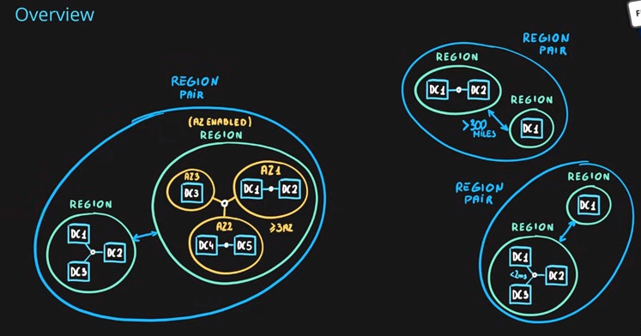

Geographies
- Discrete market
- Typically contains two or more regions
- Ensures data residency, sovereignty, resiliency, and compliance requirements are met
- Fault tolerant to protect from region wide failures
- Broken up into areas
  - Americas,
  - Europe,
  - Asia Pacific,
  - Middle East and Africa
- Each region belongs only to one Geography
